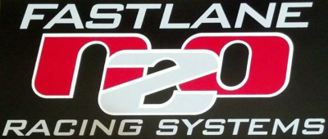

Free Tune-up: The following tunes are for the NOS Big shot plate using the 16045 Super Pro Shot Nitrous Solenoid and the 16050 Cheater Fuel:
150hp 63n/52g @ 4.25 PSI. Total timing 25-29 degrees
175hp 73n/61g @ 5.25 PSI. Total timing 25-29 degrees
200hp 82n/67g @ 5 PSI. Total timing 23-27 degrees
225hp 93n/71g @ 5.25 PSI Total Timing 23-27 degrees
250hp 102n/73g @ 5 PSI Total Timing 22-26 degrees
275hp 110n/73g @ 5.5 PSI Total Timing 20-25 degrees
-----------------------------------------------------
Tunes for the Big Shot Plate using 16048R Pro Race bottom exit nitrous solenoid and 16050 Cheater Fuel solenoid:
150+hp 63n/52g @ 4.5 PSI Total Timing 25-29 degrees
200hp 73n/63g @ 5 PSI Total Timing 23-27 degrees
225hp 82n/67g @ 5.25 PSI Total Timing 23-27 degrees
250hp 93n/73g @ 5 PSI. Total Timing 22-26 degrees
275hp 102n/78g @ 5 PSI. Total Timing 20-25 degrees
300hp 120n/78g @ 5.25 PSI. Total Timing 18-24 degrees
Total Timing depends on combustion efficiency - these are safe starting ranges. I recommend starting on low side and get the A/F ratio correct first before trying more ignition advance.
-10 or -11 heat range sparkplugs
900 +/- Bottle PSI on the starting line

